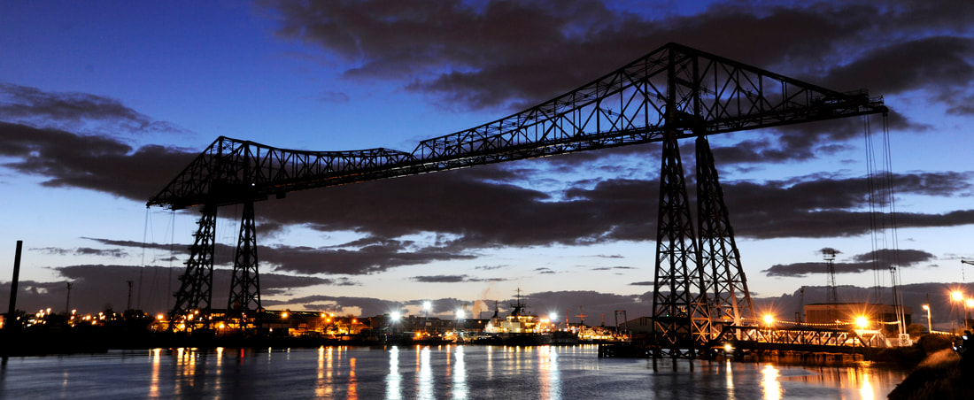

RIO group
2019 Annual Research in Imagery and Observation Group Meeting
25-26 April 2019
Teesside University, Middlesbrough, UK
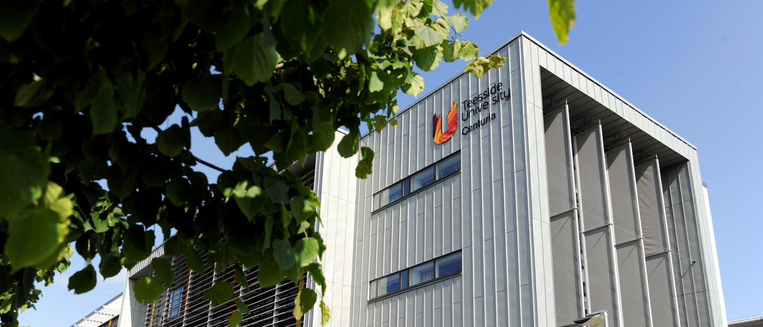

Welcome
Welcome to this year’s RIO group meeting! The RIO group organisers Daniel Eaves, Cornelia Frank, David Wright, and Adam Bruton are looking forward to seeing all group members for the 2019 RIO group meeting in the North East of England. The meeting will take place 25-26 April at Teesside University hosted by Daniel Eaves as local organiser. This year’s programme looks excellent again, with contributions from various locations across Europe and beyond. With this programme, we look forward to building on the success of recent meetings.

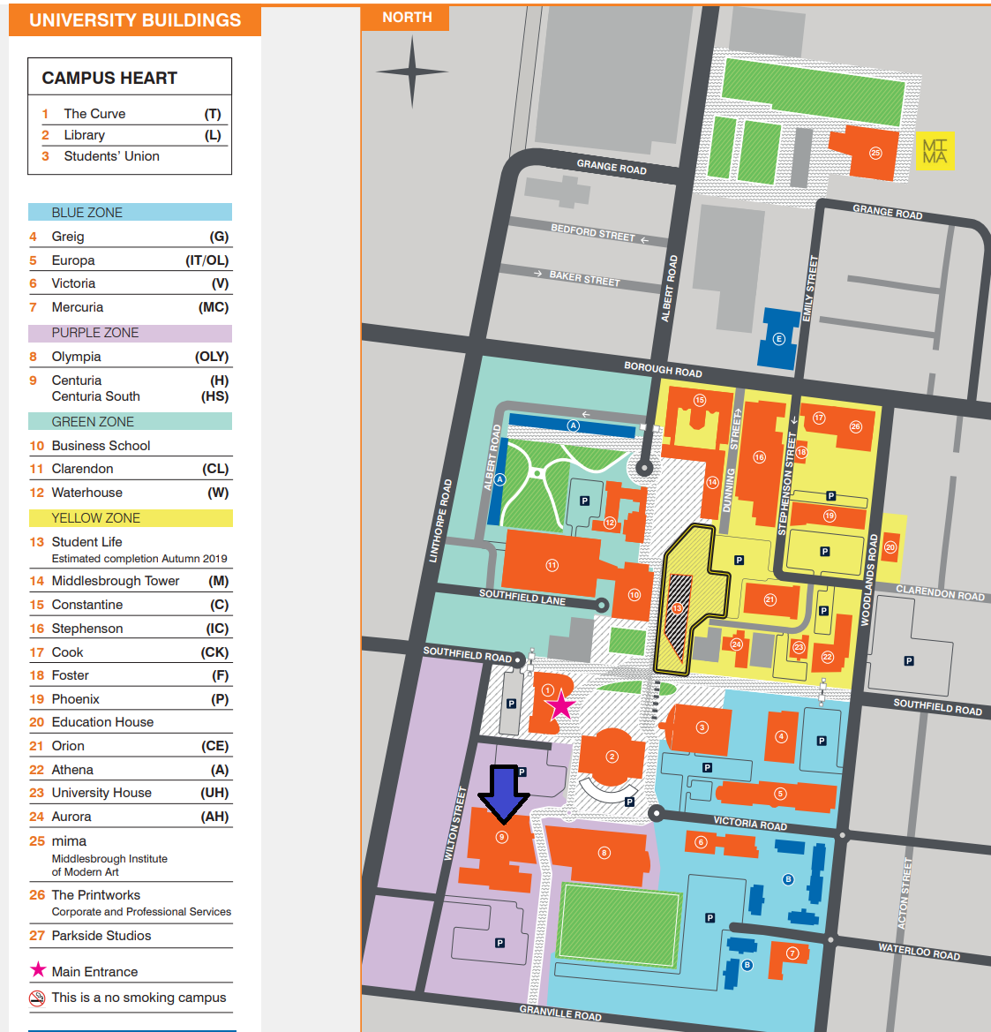
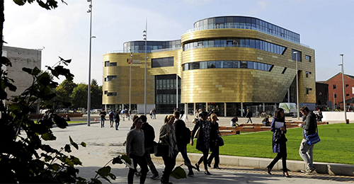
We would like to thank the School of Health and Social Care at Teesside University for providing us with financial support and a venue to host the 2019 Annual RIO Group Meeting. We would also like to thank tobii pro for their attendance and subsequent sponsorship of the meeting. Representatives of tobii pro will be demonstrating their eye-tracking equipment to delegates during the first day of the meeting and we urge those interested to discuss products with them during the day.

Venue and Travel Information
The meeting will be held in the Centuria Building (building 9),
Teesside University,
Middlesbrough,
Tees Valley,
TS1 3BX
United Kingdom.

A campus map and travel information
can be found online.

Research in Imagery and Observation
2019 Conference Schedule
Thursday 25th April

08.30 – 09.00 | Registration (Foyer in front of lecture theatre, Centuria Building)
09.00 – 09.20 | Welcome and Introduction (Lecture Theatre H0.01, Centuria Building)
09.20 – 10.40 | Oral Session 1: Motor imagery: Motor learning and rehabilitation (Lecture Theatre H0.01, Centuria Building)
09.20 | Jack P. Solomon, Sarah N. Kraeutner, Shaun G. Boe  Dalhousie University  Investigating the role of the supplementary motor area in motor imagery based skill acquisition
09.40 | Sarah N. Kraeutner, Jennifer L. McArthur, Alexandra Stratas, Shaun G. Boe  Dalhousie University  Exploring the evolution of skill acquisition via motor imagery
10.00 | Theresa Gaughan, Taylor Prentice, Shaun G. Boe  Dalhousie University  Exploring the optimal dosage of motor imagery for upper-limb rehabilitation post-stroke
10.20 | Jack A. Binks, Christopher Wilson, Paul Van Schaik, Daniel L. Eaves  Teesside University  Motor skill learning after stroke: Motor imagery during action observation enhances learning of a complex bilateral movement sequence task in the absence of physical practice
10.40 – 11.40 | Coffee Break and Poster Session: Imagery and Observation across Domains (Foyer in front of lecture hall, Centuria Building)  Complementary Tea/Coffee Available  Paul D.E. Baniqued, E. Stanyer, F. Mushtaq, M. Awais, A. Alazmani, A. Jackson, M. Mon-Williams, R. Holt  University of Leeds  Motor Imagery and Brain-Computer Interfaces for Hand Rehabilitation After Stroke: A Systematic Review  Judith Bek¹, Aline Arakaki¹, Matthew Sullivan², Ellen Poliakoff¹  ¹University of Manchester, ² Manchester Metropolitan University  The role of action representation in dance for people with Parkinson’s  Jayesha Chudasama, Gorana Pobric, Shaheen Hamdy, Cheryl Capek  University of Manchester  Using action observation, imagination and imitation to learn meaningful associations between nonsense actions and abstract symbols  Samantha Chye¹, Ceri E. Diss¹, David A. Shearer², Adam M. Bruton¹  ¹University of Roehampton, ²University of South Wales  The effects of combined action observation and motor imagery on self-efficacy and learning in Brazilian jiu-jitsu athletes  Zoe Franklin, David Wright, Paul Holmes  Manchester Metropolitan University  Using action congruent language facilitates the motor response during action observation: A combined TMS and eye tracking study  Ryan Kenny, Arash Abdolazimi, Jonathan Emmerson, Matt Scott, Paul Chesterton, Daniel L. Eaves  Teesside University  Acute treatments effects for motor imagery during action observation on postural control during quiet standing  JungWoo Lee, Sarah Kraeutner, Devan Pancura, and Shaun Boe  Dalhousie University  Duration of motor imagery performance impacts cortical excitability  Cormac McLoughlin-Gavin¹, David Shearer², Adam Bruton¹  ¹University of Roehampton, ²University of South Wales  Comparing simulation-based methods as pre-performance interventions for semi-professional cricket batsmen  Ellen Poliakoff¹, Judith Bek¹, Chesney Craig², Zoe Franklin², Matthew Sullivan², Emma Gowen¹, Stefan Vogt³, Trevor Crawford³, Paul Holmes²  ¹University of Manchester, ²Manchester Metropolitan University, ³Lancaster University  Action Imagery and Observation in Neurorehabilitation for Parkinson’s Disease (ACTION-PD): A pilot RCT of a home-based intervention to improve functional actions  Gabriel David Valadez Roque¹, Alvaro Florencio Torres Chávez²  ¹Instituto Nacional de Rehabilitación, ² Universidad Nacional Autónoma de México  Effects of action observation plus motor imagery on the recovery of paretic hand in stroke patients  Matthew Scott, Jonathan Emerson, Adam Gilmartin, Daniel Eaves  Teesside University  Motor imagery during action observation modulates automatic imitation in aging individuals  Hayley Shepherd, Judith Bek, Emma Gowen, Ellen Poliakoff  University of Manchester  How do people with Parkinson’s watch other people’s actions?  David Wright¹, Gavin Buckingham², Greg Wood¹  ¹Manchester Metropolitan University, ²University of Exeter  Corticospinal excitability markers of embodiment with a prosthesis: A pilot study  Andrei Zarie, L. O’Hare, P.M.J. Pollux  University of Lincoln  Emotional body expressions modulate steady-state visually evoked potentials
11.40 – 13.20 | Oral Session 2: Combined Action Observation and Motor Imagery: Theoretical issues and behavioural effects (Lecture Theatre H0.01, Centuria Building)
11.40 | Adam M. Bruton¹, Zoe C. Franklin², Paul S. Holmes², Daniel L. Eaves³ & David L. Wright²  ¹University of Roehampton, ²Manchester Metropolitan University, ³Teesside University  Corticospinal excitability and eye gaze markers of different combined action observation and motor imagery states
12.00 | Jonathan Emerson, Paul van Schaik, Matthew Scott & Daniel Eaves  Teesside University  fNIRS and behavioural correlates of motor imagery during action observation in people with depression and agency misattribution
12.20 | Matthew Scott, Jonathan Emerson, John Dixon, Martin Tayler & Daniel L. Eaves  Teesside University  The effect of motor imagery during action observation on imitation of familiar rhythmical actions in children with and without developmental coordination disorder
12.40 | Eoghan McNeill, Niall Ramsbottom, Adam J Toth, Mark J Campbell  University of Limerick  The combined effect of action observation and motor imagery (AO+MI) on golf putting performance
13.00 | Cornelia Frank¹, Felix Hülsmann¹, Thomas Waltemate¹, David Wright², Daniel L. Eaves³, Adam Bruton⁴, Mario Botsch¹, Thomas Schack¹  ¹Bielefeld University, ²Manchester Metropolitan University, ³Teesside University, ⁴University of Roehampton  AO+MI in virtual reality: Practicing at a level that one has not yet achieved
13.20 – 14.00 | Lunch Break (Cafeteria)  Hot Food and Sandwiches Available for Purchase
14.00 – 15.00 | Invited Talk 1 (Lecture Theatre H0.01, Centuria Building)  Richard Ramsey  Bangor University  Cognitive and brain mechanisms of social perception and interaction
15.00 – 16.00 | Coffee Break and Poster Session: Imagery and Observation across Domains (Foyer in front of lecture hall, Centuria Building)  Complementary Tea/Coffee Available  For posters, see first Coffee Break and Poster Session of 2019 RIO Meeting
16.00 – 17.00 | Research in Imagery and Observation – Fostering Collaboration/Networking Session
17.00 – 17.15 | Annual Group Meeting Photo (Entrance Hall, Centuria Building)
17.15 – 17.45 | Tobii Pro Demonstration (Lecture Theatre H0.01, Centuria Building)
18.30 | Meet for Drinks – The Dickens Pub, 4 Southfield Rd, Middlesbrough TS1 3BZ
19.30 | Conference Dinner – ‘The Oven’ restaurant 206-209 Linthorpe Rd, Middlesbrough TS1 3QW

Research in Imagery and Observation
2019 Conference Schedule
Friday 26th April

09.15 – 09.30 | Welcome and Introduction (Lecture Theatre H0.01, Centuria Building)
09.30 – 10.50 | Oral Session 3: Visual Attention and Action Observation (Lecture Theatre H0.01, Centuria Building)
09.30 | Maaike W.H.H. Esselaar, Zoe Franklin , David Wright, Dave Smith, Paul Holmes  Manchester Metropolitan University  The effect of personality type on attentional bias and its manipulation in patients with chronic back pain
09.50 | Daniel T. Smith¹, Neil Archibald², Dr Soazig Casteau¹  ¹Durham University, ² South Tees NHS Hospitals Trust  The role of the oculomotor system in spatial working memory
10.10 | Soazig Casteau, Jacob Hathaway, Amanda Ellison, Daniel T. Smith  Durham University  Do the eye-movement system and the hand-movement system contribute independently to attentional orienting: a TMS study
10.30 | Shiau-Chuen Chiou, Thomas Schack  Bielefeld University  Is temporal information integrated with spatial information during action observation? Effects of visual attention on the processing of whole-body movement sequences
10.50 | Judith Bek¹, Emma Gowen¹, Stefan Vogt², Trevor Crawford², Ellen Poliakoff¹  ¹University of Manchester, ²Lancaster University  Imitation of biological movement in Parkinson’s disease: a kinematic and eye-tracking study
11.10 – 11.50 | Coffee Break and Poster Session: Imagery and Observation across Domains (Foyer in front of lecture hall, Centuria Building)  Complementary Tea/Coffee Available  For posters, see first Coffee Break and Poster Session of 2019 RIO Meeting
11.50 – 12.50 | Invited Talk 2 (Lecture Theatre H0.01, Centuria Building)  Robert Hardwick  KU Leuven  Neural correlates of action: Comparing meta-analyses of imagery, observation, and execution
12.50 – 13.30 | Lunch Break (Cafeteria)  Hot Food and Sandwiches Available for Purchase
13.30 – 14.00 | Discussion Session (Lecture Theatre H0.01, Centuria Building)  Stefan Vogt and Daniel L. Eaves: Future Directions for Research in Imagery and Observation?
14.00 | Conference End (optional social activity)

